**Amending BOMS – Lisa Van Dyk**

Lisa’s instructions

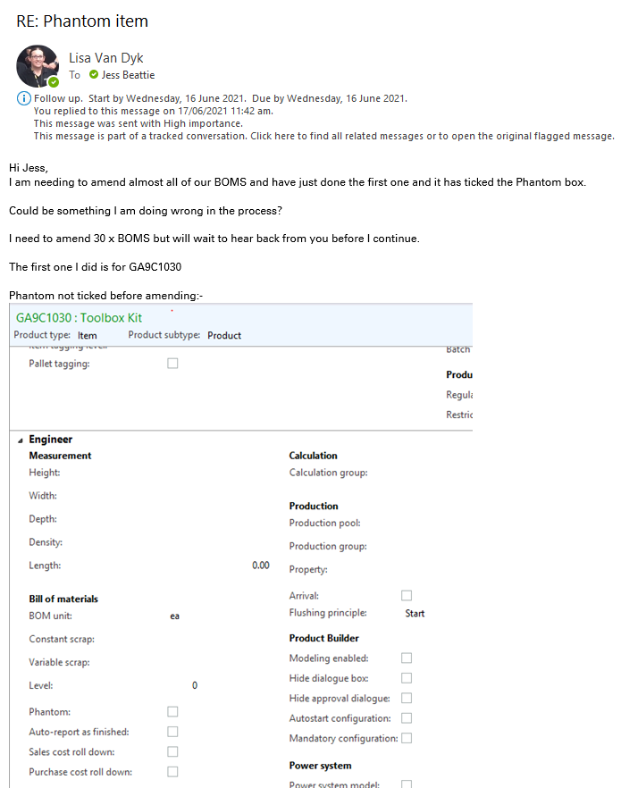

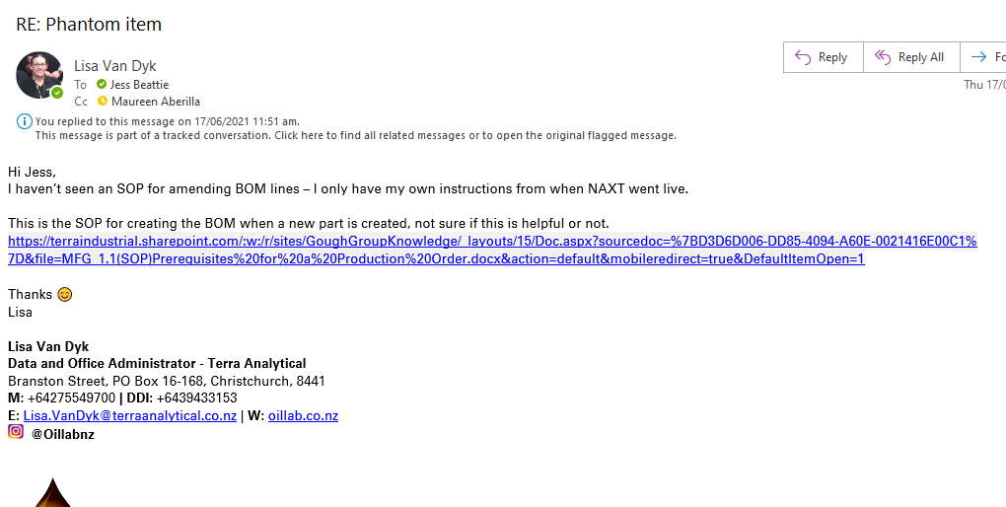

<https://terraindustrial.sharepoint.com/:w:/r/sites/GoughGroupKnowledge/_layouts/15/Doc.aspx?sourcedoc=%7BD3D6D006-DD85-4094-A60E-0021416E00C1%7D&file=MFG_1.1(SOP)Prerequisites%20for%20a%20Production%20Order.docx&action=default&mobileredirect=true&DefaultItemOpen=1>

Unapproving and Deactivating the BOM

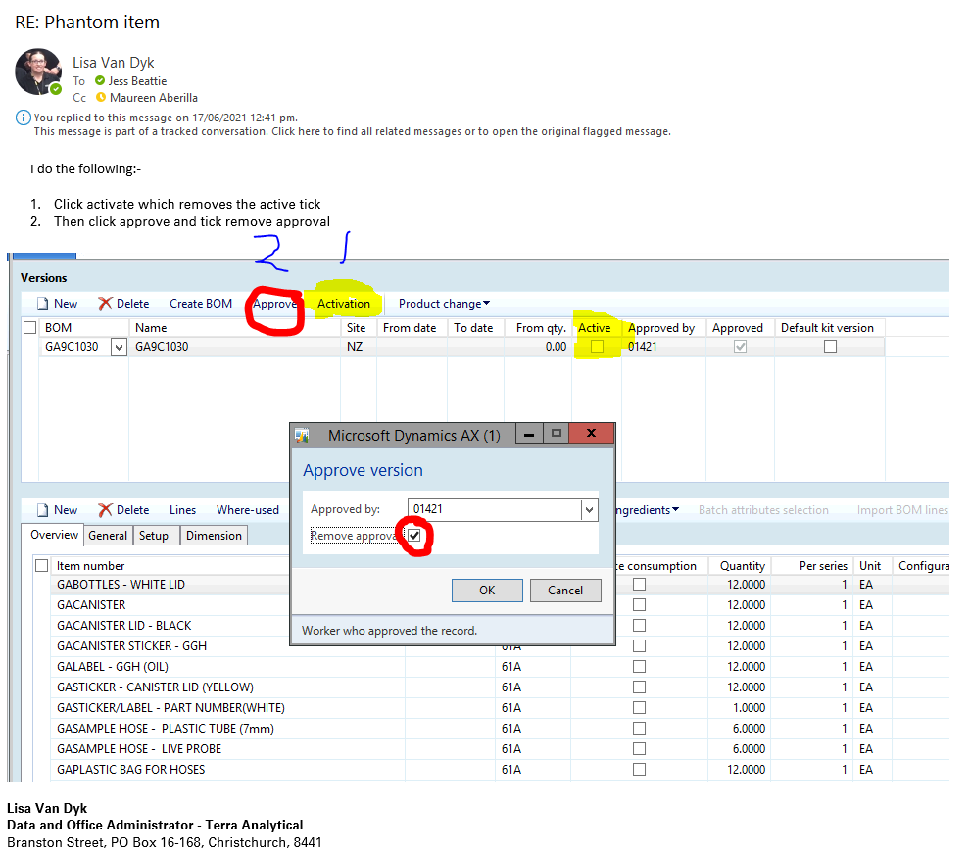

After approving

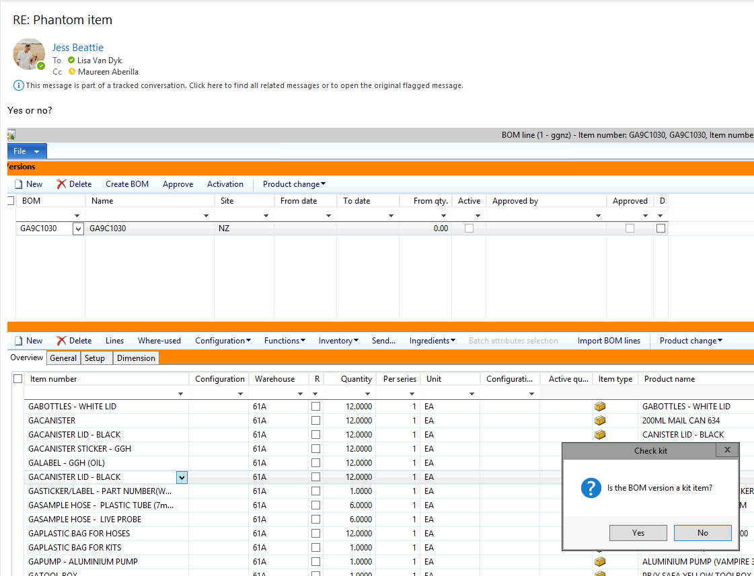

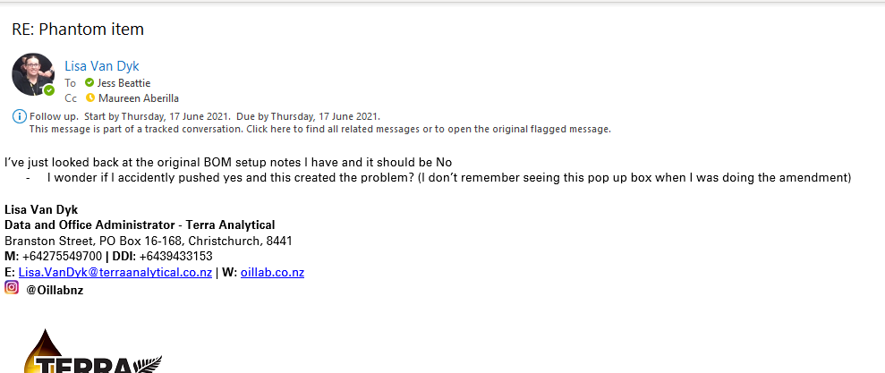

**Full process**

1. Product information management > common > released products
2. Search for product
3. Click Engineer tab
4. Select lines
5. Click Activation – this is to deactivate the BOM

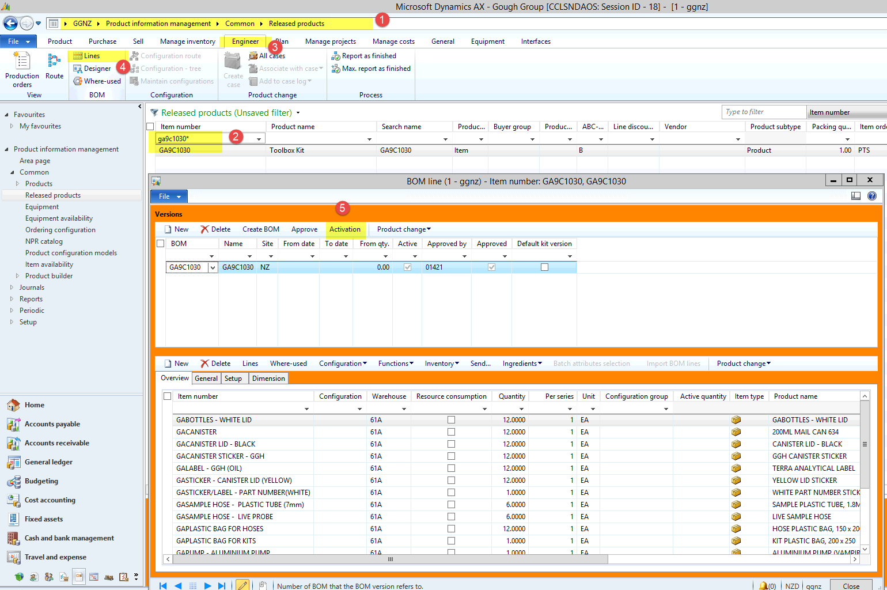

Activation box is now unticked

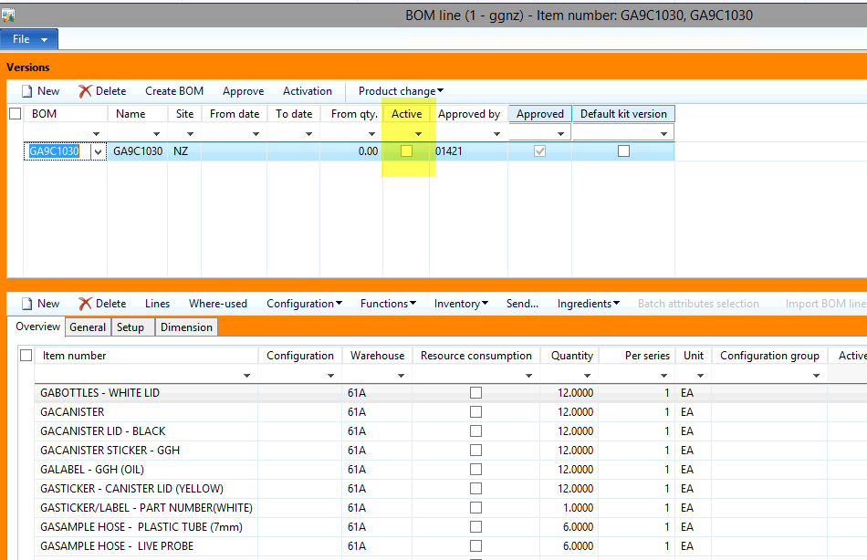

1. Click approve
2. Tick the “Remove approval” box

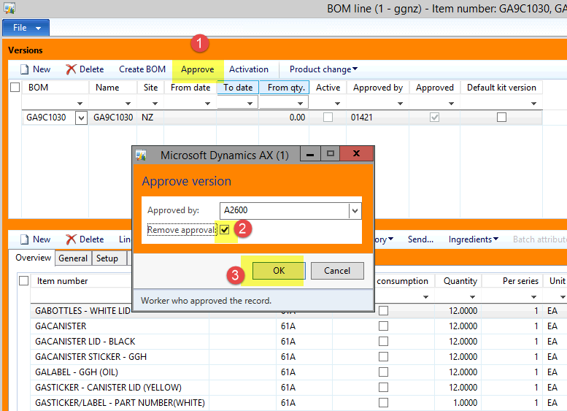

Now the approved box is unticked

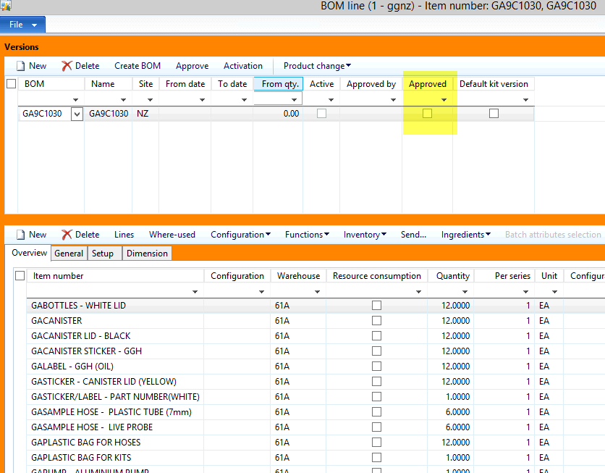

1. Change yellow canister lid to black

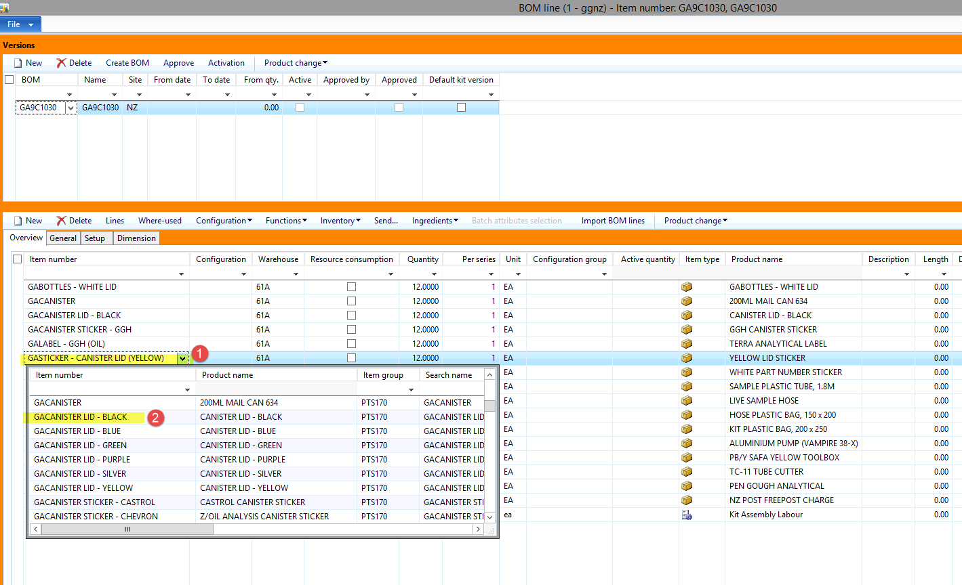

1. Click approve and select ok

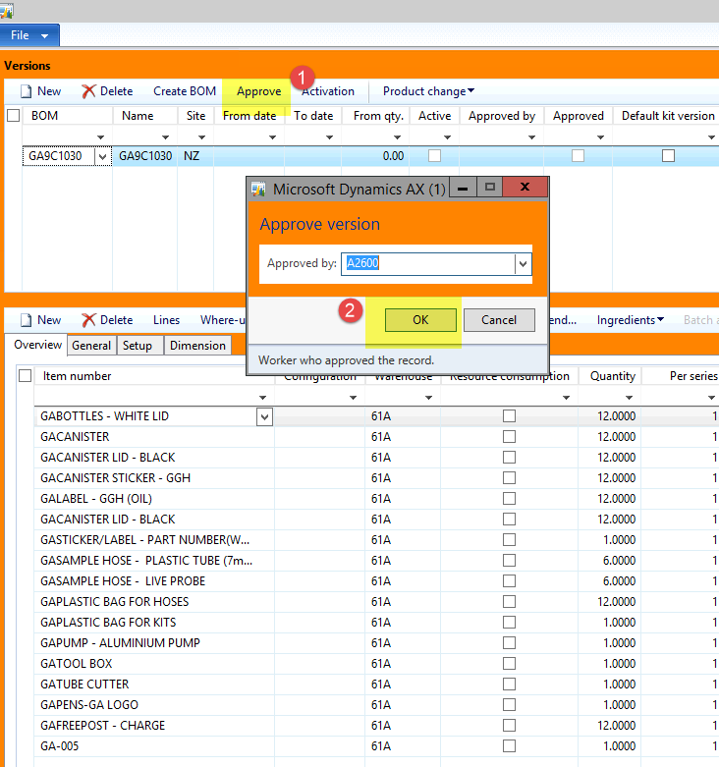

1. Select NO

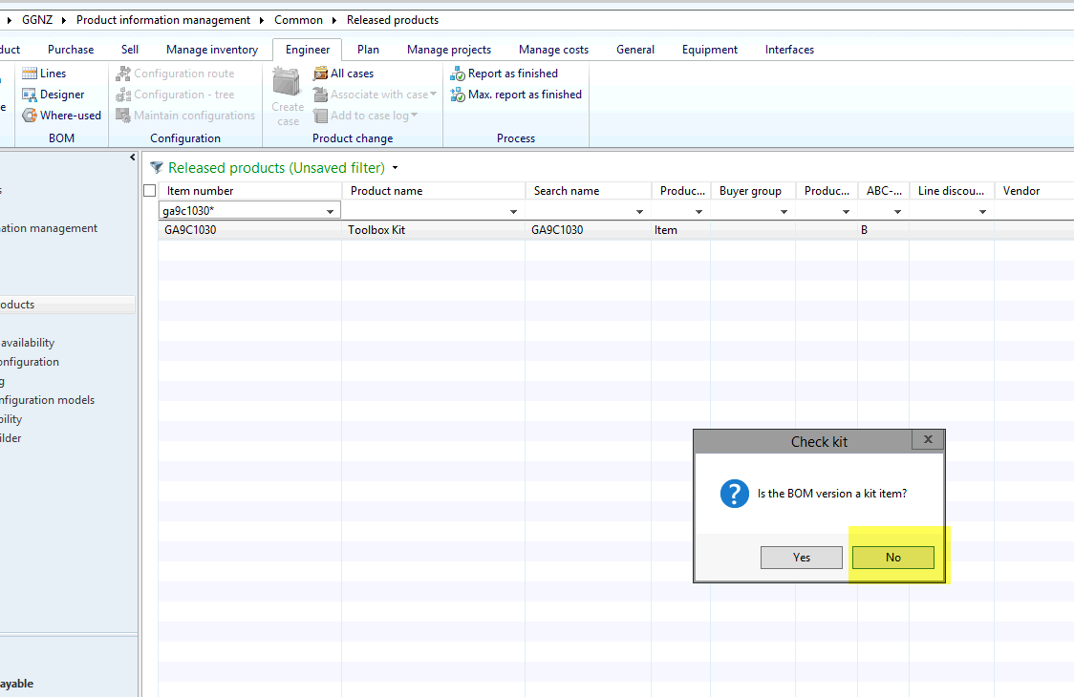

**Phantom box gets ticked on the product if you click yes**

